1. Write a console application which will read text files from mentioned file system location. And list subdirectories from mentioned folder on file system using System.IOnamespace and use DirectoryInfo, Directory, File and FileInfoClasses with all the methods present in theseclasses.

using System;

using System.IO;

namespace FileIODemo

{

public class Program

{

public static void Main()

{

try

{

string path = @"C:\Users\Swati\FileIO\";

string[] files = Directory.GetFiles(path);

string[] directories = Directory.GetDirectories(path);

Console.WriteLine($"Files in {path}\n");

foreach (string file in files)

{

string fileName = Path.GetFileName(file);

Console.WriteLine(fileName);

string filepath = Path.Combine(path, fileName);

FileInfo myfile = new FileInfo(filepath);

// Opening file to read

StreamReader sr = myfile.OpenText();

string data = "";

while ((data = sr.ReadLine()) != null)

{

Console.WriteLine(data);

}

Console.WriteLine("\n");

}

Console.WriteLine($"Subdirectories inside {path}\n");

foreach (string directory in directories)

{

DirectoryInfo directoryinfo = new DirectoryInfo(directory);

directoryinfo.GetDirectories();

string directoryName = directoryinfo.Name;

Console.WriteLine(directoryName);

}

}

catch (IOException e)

{

Console.WriteLine(e);

}

}

}

}

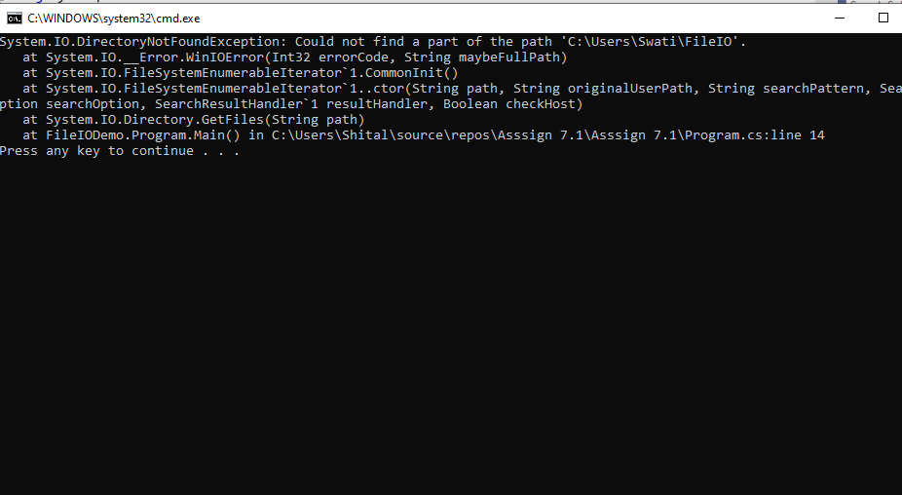

2. Create a simple user interface to accept account related information of a customer.[ Account class from Lab session on Delegates and Events can be used]. Save the information about the customers in a file using StreamWriterand retrieve the information using StreamReader.

using System;

using System.Collections.Generic;

using System.Linq;

using System.Text;

using System.Threading.Tasks;

namespace que7

{

class BankAccount

{

public double AccountNumber;

public string Name;

public double bankbalance;

public void data()

{

Console.WriteLine("enter account number");

AccountNumber = Convert.ToInt32(Console.ReadLine());

Console.WriteLine("enter name");

Name = Console.ReadLine();

Console.WriteLine("bank balance");

bankbalance = Convert.ToInt32(Console.ReadLine());

Console.WriteLine("Account number={0}\nname={1}\nbank balance={2}", AccountNumber, Name, bankbalance);

string filepath = @"c:\users\c# .net Assignments\bank details.txt";

StreamWriter sw = File.CreateText(filepath);

sw.WriteLine("account number=" + AccountNumber);

sw.WriteLine("name=" + Name);

sw.WriteLine("bankbalance=" + bankbalance);

sw.Close();

Console.WriteLine("---data reading---");

using (StreamReader sr = File.OpenText(filepath))

{

String s = "";

while ((s = sr.ReadLine()) != null)

{

Console.WriteLine(s);

}

}

}

class filedata

{

public static void Main()

{

try

{

BankAccount b = new BankAccount();

b.data();

}

catch (Exception ex)

{

Console.WriteLine(ex.GetType().Name);

}

}

}

}

}

3.Make the Employee, MarketingExecutiveand Manager class as Serializable

created in LitwareLib.dll.

4.Create a user interface to accept information about Manager(For simplicity accept only employee id , name and basic salary). Serialize the object using Binary Serialization and retrieve its information by deserializing theobject.

using System;

using System.IO;

using System.Runtime.Serialization;

using System.Runtime.Serialization.Formatters.Binary;

using LitwareLib;

namespace CSharp_Assignment2

{

[Serializable]

class Program

{

public static void Main()

{

try

{

Console.WriteLine("enter no.of employee");

int size = Convert.ToInt32(Console.ReadLine());

Employee[] obj1 = new Employee[size];

Employee obj = new Employee();

List<string> list = new List<string>();

Console.WriteLine("----------Accepting Employee Details----------");

for (int i = 0; i < obj1.Length; i++)

{

Console.WriteLine("Enter Employee Number:");

int no = int.Parse(Console.ReadLine());

obj.setempno(no);

Console.WriteLine("Enter Employee Name:");

string name = Console.ReadLine();

obj.setempname(name);

list.Add(name);

Console.WriteLine("Enter Employee Salary:");

double salary = double.Parse(Console.ReadLine());

obj.setEmpSalary(salary);

//obj.sethra();

//obj.setta();

//obj.setda();

//obj.setgs();

//obj.calculatesalary();

}

FileStream f = new FileStream(@"D:\train\c# .net Assignments\employee details.txt", FileMode.Open, FileAccess.Write);

BinaryFormatter b = new BinaryFormatter();

b.Serialize(f, obj1);

f.Close();

Console.WriteLine("----------displaying Employee Details----------");

for (int i = 0; i < obj1.Length; i++)

{

obj.getEmpNo();

obj.getEmpName();

obj.getEmpSalary();

obj.getgs();

}

Console.WriteLine("deserialization");

FileStream fr = new FileStream(@"D:\train\c# .net Assignments\employee details.txt", FileMode.Open, FileAccess.Read);

BinaryFormatter br = new BinaryFormatter();

br.Deserialize(fr);

foreach (string e in list)

{

Console.WriteLine(e);

}

Console.WriteLine("enter the employee name to search");

string target = Console.ReadLine();

bool isexist = list.Contains(target);

if (isexist)

{

Console.WriteLine("Element found in the list");

}

else

{

Console.WriteLine("Element not found in the given list");

}

}

catch (Exception ex)

{

Console.WriteLine(ex.GetType().Name);

}

}

}

}